Working screenshot of the Assignments are attached from the next page .
In this page I’m explaining the Major workflow of the Jira connection and data retrieval

Frontend
App.tsx -> Gets the Jira details from the Frontend UI and also reads the Summary, title,description,acceptance criteria details from the jira board
Server.ts -> this file will route to the jira to establish the connection with our Agent to fetch the jira stories

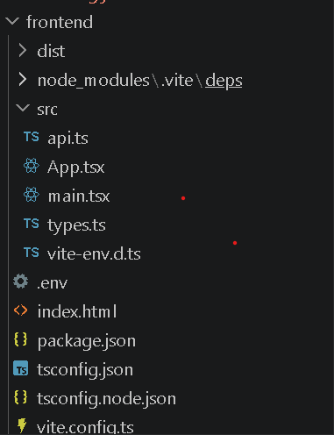

Backend

Jira.ts -> Backend API calls to jira happens by the specifications in this file
Generate.ts -> Connects in the backing with the Groq Client.

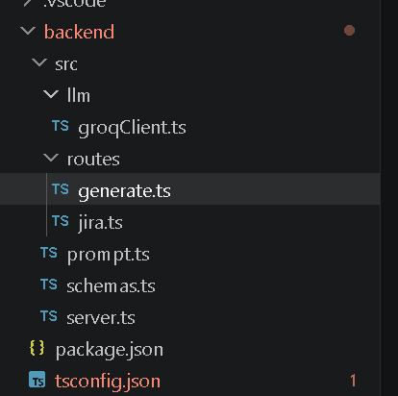

Connecting to the Jira and fetching result
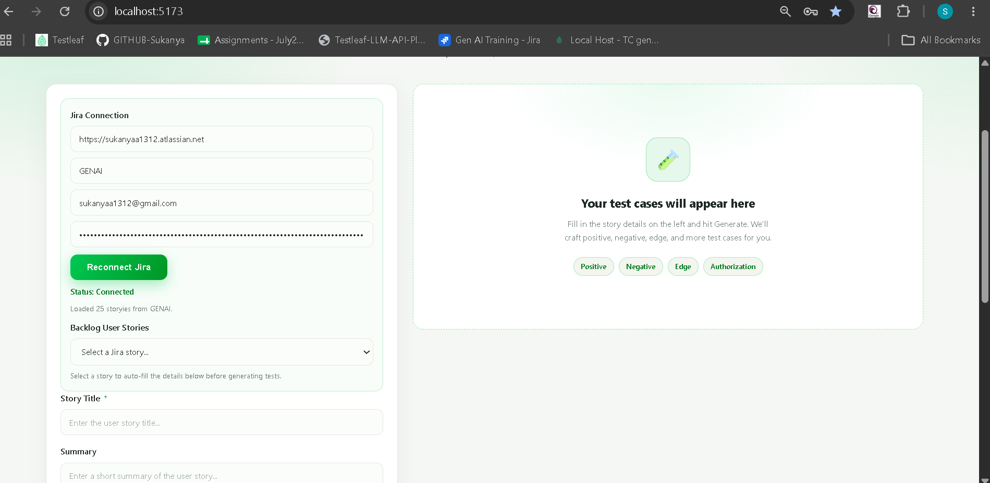

Selecting the User story and its details are displayed in the User story details text boxes
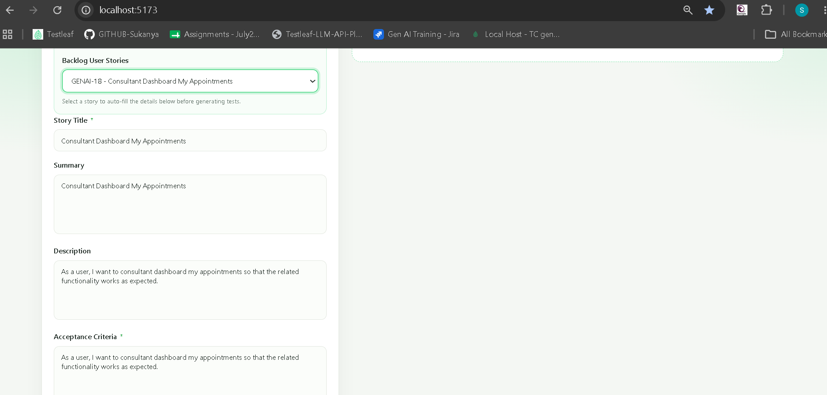

Now generate the test cases
